Getting to Know Your Child

Toys and Objects | Favorite | Least Favorite
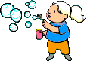

Favorite | Least Favorite | People and Playmates

Activities and Games | Favorite | Least Favorite


Favorite | Least Favorite | Food and Drinks
 | Any Allergies? | 

Places | Favorite | Least Favorite
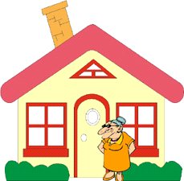

 | How does your child let you know what he/she likes? | How does your child let you know what he/she doesn't like?

When is your child most cooperative? | When is your child least cooperative?
 |  | 

 | What frightens your child? | What calms your child?
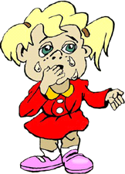

How does your child assist/participate in the following daily routines?

Feeding | Dressing
 |  | 

 | Bathing | Toileting
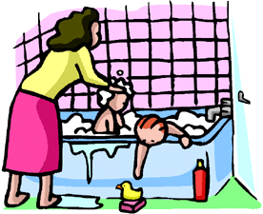

What do you think helps  your child learn? | What would you like to  learn about your child?
 |  | 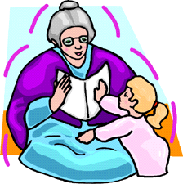

What else would you like us to know about your child?
___________________________________________________________________________________________________________________________________________________________________________________________________________________________________________________________________________________________________________________________________________________________________________________________________________________________________________________________________________________________________________________________________________________________________________________________________________

THANK YOU!

Adapted from: Noonan, M.J., & McCormick, L. (1993). Early Intervention in Natural Environments: Methods and procedures. Pacific Grove, CA. Brooks/Cole.

